Latest Round-ups:
Season 2019/20
#3
Midweek Action: A stunning spell at the end of the first half helped fire Cribbs into the next round of the FA Cup at the expense of Western League opponents Wellington. Having taken a third minute lead through Charlie Aldom, Cribbs then sprung to life just before the interval, with Jacob Hodgson, Joe White and George Kellow all scoring in the space of four minutes. Kellow then added a fifth in the early stages of the second half, with Ian Bellinger scoring a late free-kick for the shell-shocked visitors.
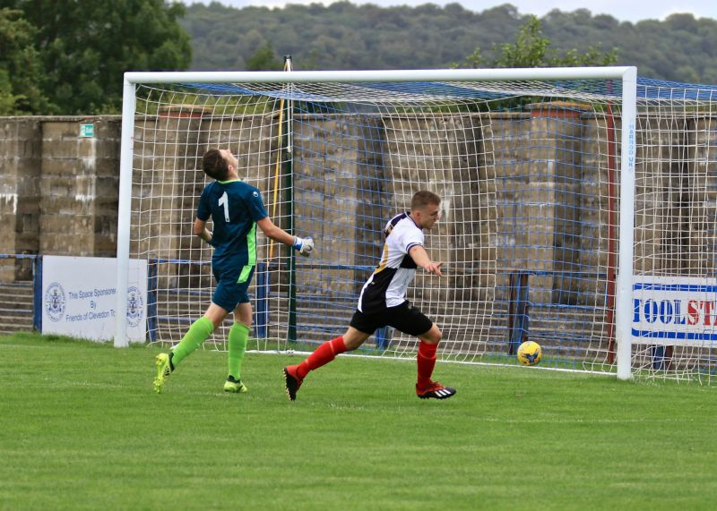
Premier Division: Plymouth Parkway’s 5-0 win away at Bridport maintained their excellent start to the campaign. Having taken a two-goal lead into the break thanks to Mikey Williams and Jack Calver, Parkway exerted their dominance in the second half, with an own goal adding to further strikes from Williams and Adam Carter at St Mary’s Field. Bradford Town are another side who extended their winning run to start the season, with two goals in either half landing them a 4-2 victory away at Tavistock. Tyson Pollard played a starring role for the Bobcats, assisting Gary Higdon’s opener, before adding a goal of his own, with the hosts trimming the deficit on the stroke of half-time through Liam Prynn. Substitute Lewis Powell then restored Bradford’s two-goal advantage, with Pollard scoring his second of the afternoon prior to Tavistock’s late consolation from the penalty spot. Exmouth Town continued their perfect start, with a highly impressive 1-0 win away at Bitton. In an early season clash between two of the pre-season title favourites, it was Exmouth who came away with all three points thanks to a first half strike from Ace High. Odd Down’s opening home clash of the season ended in a big win, with the Bath-side downing Brislington by five goals to one. Early goals from Curtis Dunn and Reeko Best handed Odd Down a dream start to the contest, with Brislington hitting back from the spot through Jayden Neilson after Oaklan Buck had been felled in the box. A wickedly hit set-piece from Dunn extended Odd Down’s lead to two once more, with Adnan Hiroli and Dane Edwards then converting from corners during the second half to complete the five-goal performance. Having claimed only one point from their opening two fixtures, Bridgwater’s first league win of the season came thanks to a magnificent 8-1 triumph away at Chipping Sodbury Town. Having moved into a two-goal lead thanks to Jack Taylor and David O’Hare, Bridgwater’s position looked to have improved further when Justin Bishop was given his marching orders for the hosts. In fact, that red card seemed to boost Chipping Sodbury, with their form marksman Sam Makepeace maintaining his record of scoring in all four of their clashes so far this season. Bridgwater weren’t deterred however, putting the ten-men to the sword after the break, with Sam Towler, Jamie Laird and Steve Murray all scoring within five minutes of the restart. The visitors continued to attack throughout the second period, with Murray and O’Hare each completing doubles, and Jake Llewellyn also adding his name to the scoresheet. Goals in either half from Dan Linham helped Street defeat Keynsham Town 2-1 at the Tannery Ground, while Buckland handed Wellington a 2-0 defeat in Devon courtesy of efforts from Richard Groves and second-half substitute Ryan Bush. Clevedon and Shepton Mallet shared the points after battling out a highly-entertaining 2-2 draw at the Hand Stadium in Somerset. Jack Fillingham’s brace looked set to hand Shepton all three points, with Elliot Nicholson grabbing a lifeline for Clevedon in the final 15 minutes. Alex Twiggs was then dismissed for the hosts, with Fillingham missing out on the opportunity of a hat-trick after seeing his resulting spot kick ricochet back off the goalpost. The Seasiders took full advantage of Shepton’s missed spot kick, with Lucas Vowles grabbing a late equaliser, but that wasn’t the end of the late drama with the ten men afforded a chance at all three points, but Vowles saw his own injury time penalty saved by Shepton keeper Jonny Hill as the game ended level. The closing stages at Springfield also proved to be vital to the game’s outcome, with Cadbury Heath claiming a come-from-behind 2-1 victory over Cribbs. Having fallen behind in the 12th minute to George Neill’s opener, Heath found their way back into the contest thanks to Josh Williams’ leveller, with Callum Ball then powering home a bullet header five minutes from time to complete the turnaround. Hallen responded to suffering a heavy defeat on the opening day by winning 2-1 away at Roman Glass St George, with Kyle Thomas’ long range opener cancelled out by the hosts before Elliot Gibbons scored the visitors winner seven minutes from time.
Action from Street’s 2-1 victory over Keynsham courtesy of John Pool.
Jack Fillingham wheels away after scoring for Shepton Mallet during their 2-2 draw with Clevedon

First Division: The First Division action got underway on Friday evening, with Cheddar leapfrogging opponents Calne Town following a 4-1 victory at Bowdens Park. The Cheesemen went ahead in the 18th minute thanks to a looping header from Dean Griffiths, with James Difford then scoring his first for the club to double the lead. A red card to Robbi Maggs threatened to alter the direction of the points, but the ten-men pushed on after the break, adding to their advantage thanks to further goals from Adam Wright and then Griffiths once more. Calne scored a consolation through Josh Hard 15 minutes from time, but that was all they could muster as they fell to their first defeat of the campaign.

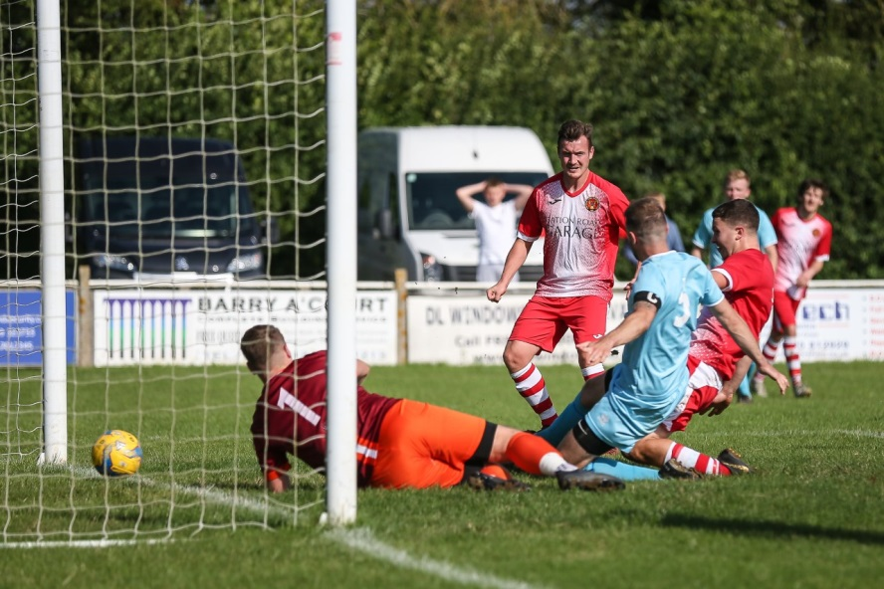
Of the eight contests which took place on Saturday afternoon, the only victory for a home side came at Raleigh Grove where goals from Haydn Hodges and Joe Smith fired Sherborne Town to a 2-1 win over Bristol Telephones. One of the visiting teams to secure all three points were Bishops Lydeard who held off a late challenge from Corsham to win 3-2 at the Southbank Ground. Having scored seven goals on their travels a fortnight earlier, Lydeard were in the mood once more and led by three goals after Ben Hedbitch, Ryan Brereton and Ben Cottrell all found the back of the net. Corsham threatened to snatch an improbable point in the closing stages, and came very close to doing so, after late goals from Jon Bazley and Lewis McCarron had helped to set up a grandstand finish. Radstock Town handed Hengrove their second defeat to start the season, scoring three times after the break to cap a 4-1 win at Paprika Park. The Miners held the upper hand for much of the first half, and their breakthrough finally came in the 22nd minute when Sam Gregory headed home a Morgan Skipp corner. The home side managed to get back on level terms through substitute Simon Knight, but that goal seemed to kickstart Radstock into life, with a quick-fire double from Skipp and Gregory handing them a two-goal lead. Skipp’s excellent individual performance was completed late on when he laid on the assist for James Rustell who tucked home the visitors fourth. Fabian McCarthy’s double helped Lebeq United overturn a half-time deficit on their way to a 2-1 victory away at Warminster Town. The home side enjoyed a derby-day win last weekend, and were on their way to another three points at half-time on Saturday thanks to a whipped free-kick from Ashton Shanley. New boys Lebeq battled back on the hour mark thanks to McCarthy’s first of the afternoon, with the same man then scoring in similar fashion three minutes from time to complete an excellent second half display.
Jon Bazley slides home a late goal for Corsham during their 3-2 defeat at the hands of Bishops Lydeard. Image courtesy of John Cuthbertson.
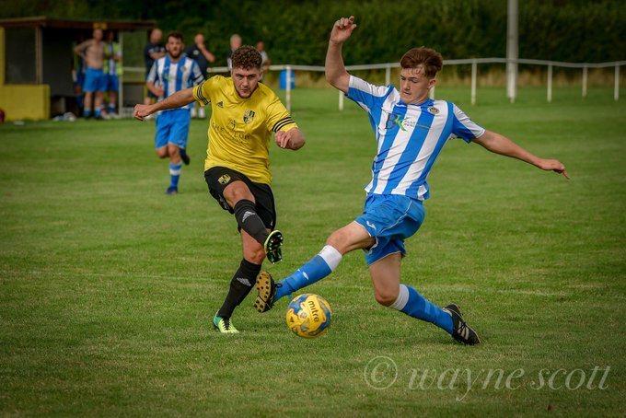
Ashton & Backwell United secured their first three point haul of the season, ending Wells’ winning run in the process, with two goals from Calum Townsend and a first half strike from Paul Uppington giving them a 3-1 victory at the Athletic Ground. Wincanton and Oldland each consolidated promising starts to their campaigns after playing out a free-flowing 2-2 draw in South Somerset. The hosts remain unbeaten after three matches, and it was they who made the early running, with Louis Irwin firing home a 10thminute opener. Oldland then enjoyed a fantastic spell midway through the first half, with Owen McCallum crossing for Joe Beardwell’s equaliser, before the same combination switched roles when McCallum put the visitors ahead. The O’s looked to have done enough to close out the victory, but Wincanton kept up the pressure, and with five minutes left on the clock, Irwin turned the ball home to salvage a point. Sam Crumb struck for the second time this season to hand Longwell Green Sports a 1-0 win away at Bishop Sutton, while a long range effort from Mitch Osmond and a spot kick from Louie Elliot handed Portishead a 2-1 victory away at Almondsbury for whom Dan Lane scored 15 minutes from time.
Action from Wincanton’s 2-2 draw with Oldland Abbotonians. Image courtesy of Wayne Scott Photography.
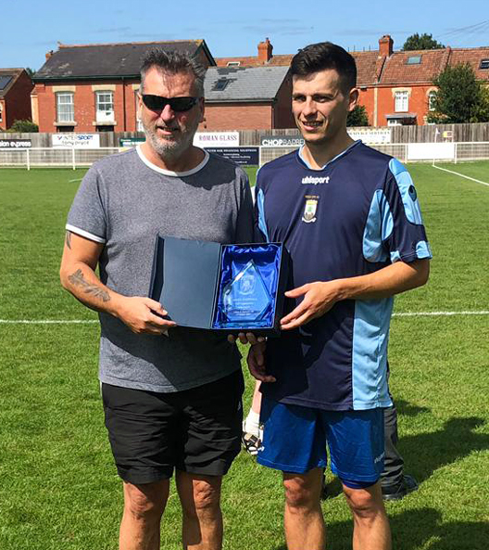
Randall reaches 600!
Congratulations to Mark Randall of Wells City who played his 600th competitive fixture for the club on Saturday afternoon.
Randall completed the achievement in their home clash with Ashton & Backwell United, before being handed his award by father, and President of Wells City, Paul Randall.

Latest Results
Tuesday 13th August 2019
FA Cup Extra Preliminary Round Replay
Cribbs 5-1 Wellington
Friday 16th August 2019
First Division
Cheddar 4-1 Calne Town 77
Saturday 17th August 2019
Premier Division
Bitton 0-1 Exmouth Town 107
Bridport 0-5 Plymouth Parkway 153
Buckland Athletic 2-0 Wellington 102
Cadbury Heath 2-1 Cribbs 83
Chipping Sodbury Town 1-8 Bridgwater Town
Clevedon Town 2-2 Shepton Mallet 102
Odd Down 5-1 Brislington 49
Roman Glass St George 1-2 Hallen 70
Street 2-1 Keynsham Town 86
Tavistock 2-4 Bradford Town
First Division
Almondsbury 1-2 Portishead Town 57
Bishop Sutton 0-1 Longwell Green Sports 32
Corsham Town 2-3 Bishops Lydeard 102
Hengrove Athletic 1-4 Radstock Town 45
Sherborne Town 2-1 Bristol Telephones 77
Warminster Town 1-2 Lebeq United 127
Wells City 1-3 Ashton & Backwell United 38
Wincanton Town 2-2 Oldland Abbotonians 56
Reporter Wanted
An opportunity has arisen to compile the Western League report for publication in the Non-League Paper. The paid position requires a weekly report covering the Premier Division fixtures every Saturday afternoon.
If you require any more information regarding the role, please contact Dave Watters on 07950 953505 or at dave.watters@greenwayspublishing.com, he would be keen to speak to anybody interested and is hoping to attract a local reporter to cover the league.

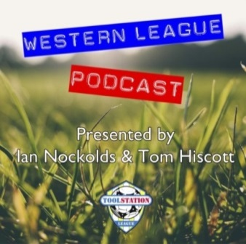

Be sure to check out the latest podcast, where Ian, Tom & guests recap all the latest news and results from around the Western League. To follow along all season, each broadcast will be available at the following link: http://www.toolstationleague.com/podcasts.php

Upcoming Fixtures
Monday 19th August 2019
First Division
Calne Town vs Hengrove Athletic 19:45KO
Tuesday 20th August 2019
Premier Division
Bridport vs Shepton Mallet 19:45KO
Brislington vs Cadbury Heath 19:30KO
Chipping Sodbury Town vs Bradford Town 19:45KO
Cribbs vs Bitton 19:45KO
Keynsham Town vs Roman Glass St George 19:45KO
Street vs Wellington 19:45KO
First Division
Devizes Town vs Welton Rovers 19:30KO
Wednesday 21st August 2019
Premier Division
Clevedon Town vs Odd Down 19:45KO
Plymouth Parkway vs Exmouth Town 19:30KO
Tavistock vs Buckland Athletic 19:30KO
Westbury United vs Hallen 19:30KO
Saturday 24th August 2019 (KICK OFF AT 3.00PM UNLESS NOTED)
FA Cup – Preliminary Round
Bitton vs Mangotsfield Town
Bradford Town vs Larkhall Athletic
Bridgwater Town vs Brislington
Clevedon Town vs Bristol Manor Farm
Cribbs vs Bideford
Didcot vs Roman Glass St George
Plymouth Parkway vs Paulton Rovers
Shepton Mallet vs Melksham Town
Street vs Willand Rovers
Tavistock vs Frome Town
Yate Town vs Exmouth Town
Premier Division
Buckland Athletic vs Chipping Sodbury Town
Cadbury Heath vs Bridport
Odd Down vs Wellington
First Division
Almondsbury vs Hengrove Athletic
Ashton & Backwell United vs Longwell Green Sports
Bishops Lydeard vs Sherborne Town
Bristol Telephones vs Corsham Town
Calne Town vs Bishop Sutton
Lebeq United vs Cheddar
Portishead Town vs Warminster Town
Radstock Town vs Wells City
Welton Rovers vs Oldland Abbotonians
Wincanton Town vs Devizes Town

